**Java**  program to check if given linked list has a loop or not.

**package** Tuesday;

**public** **class** LinkedList {

**private** Node head;

**private** **static** **class** Node {

**private** **int** value;

**private** Node next;

Node(**int** value) {

**this**.value = value;

}

}

**public** **void** addToTheLast(Node node) {

**if** (head == **null**) {

head = node;

} **else** {

Node temp = head;

**while** (temp.next != **null**)

temp = temp.next;

temp.next = node;

}

}

**public** **void** printList() {

Node temp = head;

**while** (temp != **null**) {

System.***out***.format("%d ", temp.value);

temp = temp.next;

}

System.***out***.println();

}

**public** **boolean** ifLoopExists() {

Node fastPtr = head;

Node slowPtr = head;

**while** (fastPtr != **null** && fastPtr.next != **null**) {

fastPtr = fastPtr.next.next;

slowPtr = slowPtr.next;

**if** (slowPtr == fastPtr)

**return** **true**;

}

**return** **false**;

}

**public** **static** **void** main(String[] args) {

LinkedList list = **new** LinkedList();

// Creating a linked list

Node loopNode=**new** Node(7);

list.addToTheLast(**new** Node(5));

list.addToTheLast(**new** Node(6));

list.addToTheLast(loopNode);

list.addToTheLast(**new** Node(1));

list.addToTheLast(**new** Node(2));

list.printList();

// creating a loop

list.addToTheLast(loopNode);

// Test if loop existed or not

System.***out***.println("Loop existed-->" + list.ifLoopExists());

}

}

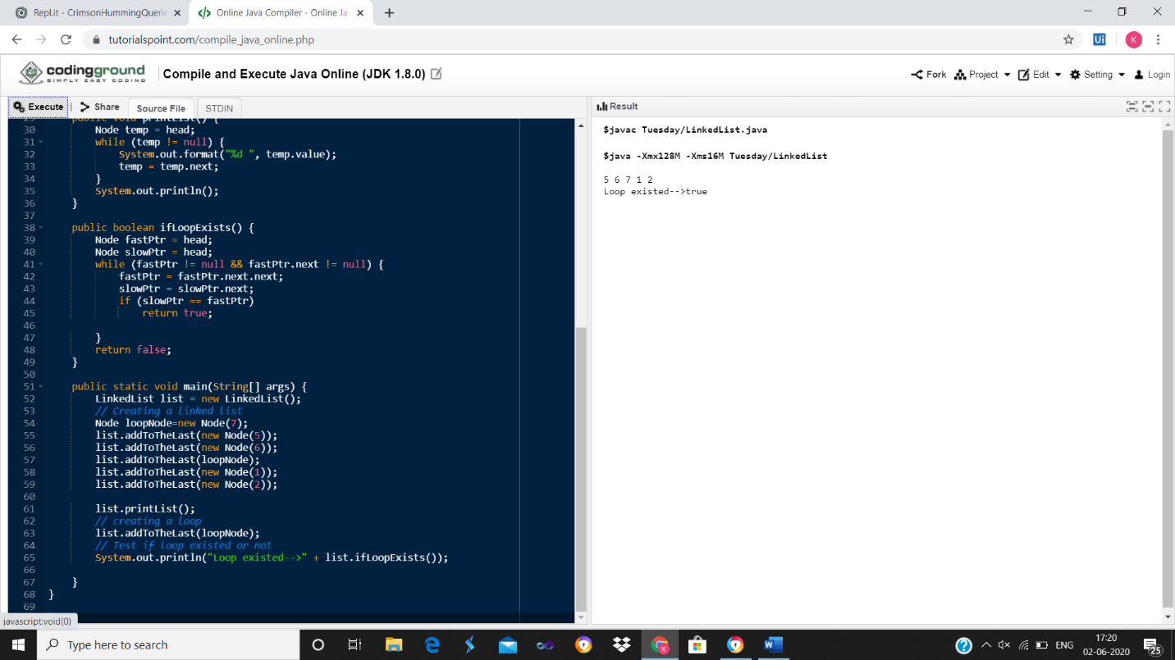

public static void main(String[] args) {

LinkedList list = new LinkedList();

// Creating a linked list

list.addToTheLast(new Node(5));

list.addToTheLast(new Node(6));

list.addToTheLast(new Node(7));

list.addToTheLast(new Node(1));

list.addToTheLast(new Node(2));

list.printList();

// Test if loop existed or not

System.out.println("Loop existed-->" + list.ifLoopExists());

}

